Promoting Low Carbon Urban Development in Bangladesh

GEF Secretariat Review for Full Sized Project – GEF - 6
Basic Information
GEF ID
9368
Countries
Bangladesh
Project Title
Promoting Low Carbon Urban Development in Bangladesh
GEF Agency(ies)
UNDP
Agency ID
UNDP: 5571
GEF Focal Area(s)
Climate Change
Program Manager
Ming Yang

PIF
CEO Endorsement
Project Design and Financing

1. If there are any changes from that presented in the PIF, have justifications been provided?
Secretariat Comment at CEO Endorsement
9/3/2019 MY:
There is not any significant change from the PIF to CE ER.

Response to Secretariat comments

sans-serif

2. Is the project structure/ design appropriate to achieve the expected outcomes and outputs?
Secretariat Comment at CEO Endorsement
9/3/2019 MY:
Not completed at this time.
In project design, it is not clear how to use $65 million loan investment in RE and EE. Please provide details on it.
10/31/2019 MY:
Not completed at this time. Please put targeted numbers of RE and EE projects, targeted capacity installations of RE in MW, and targeted energy savings in MWh or tonnes of oil equivalent in "Component 2.2 Implemented low-carbon investments in public and private buildings and built environment", and split the $65 million loan investment to match each of the investment projects and their outputs.
11/14/2019 MY:
Not at this time.
In Table B (PROJECT DESCRIPTION SUMMARY) in the GEF Portal and in the attached CEO ER document, please put targeted numbers of RE and EE projects, targeted capacity installations of RE in MW, and targeted energy savings in MWh or tonnes of oil equivalent.
4/27/2020 MY:
Yes, comments were addressed, and the CEO ER document was revised.

Response to Secretariat comments

sans-serif

Response to 11/14/2019 MY:
Thanks for this Guidance. Table B in the CEO ER is revised to include the information requested.

UNDP response 13 Nov 2019
Box 8 (see below) has been expanded to include further details including (i) targeted capacity for RE/target energy savings for EE and (ii) an indicative debt financing component from the IDCOL facility.
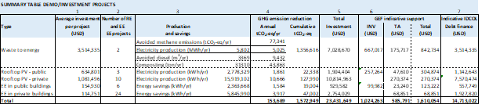

Oct. 29, 2019 - MH

The project’s Component 2 has two core outputs:
• First, a set of TA activities to provide support to public and private sector developers to advance the funding requests for their RE, EE and WTE investments. This will take the form of a call for proposals, providing energy audit, business/financial plan support.
• Second, a set of INV activities, with a viability gap mechanism to provide financial support to investments which are not financially viable with baseline financial terms and structuring.

Box 8 in the UNDP project document (page 45), sets out a preliminary analysis which has identified 45 indicative RR, EE and WTE investments, totaling USD 23.4 million, for which the project could provide support under component 2. This box is re-pasted below, for ease of reference.

Box 8: Indicative public and private sector low-carbon investments associated with the LCUD Project.

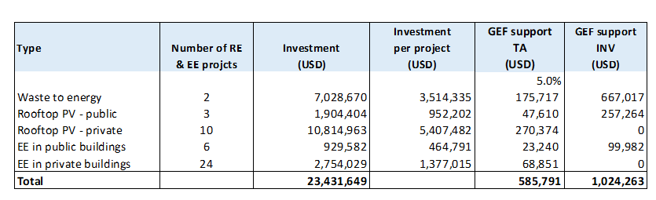

In parallel to the above, IDCOL has a USD 65m loan facility for rooftop solar and EE investments. Consultations with IDCOL have identified that project developers are not presenting bankable investment opportunities for the loan facility. The relationship of this IDCOL facility to the project is that this IDCOL facility will be one possible source of financing for the project’s indicative investments, represented in Box 8. However, the indicative investments in Box 8 will also seek to raise financing from other debt and equity providers. IDCOL can be considered parallel co-financing, which is associated and well-aligned with the project, and for which there will be close coordination with project.

3. Is the financing adequate and does the project demonstrate a cost-effective approach to meet the project objective?
Secretariat Comment at CEO Endorsement
9/3/2019 MY:
Not completed at this time.
It is difficult to judge the cost-effectiveness of the project, since there is not detailed information on the $65 million of loan investment. Per the co-financing letter from the loan provider (IDCOL), the following tasks will be undertaken:
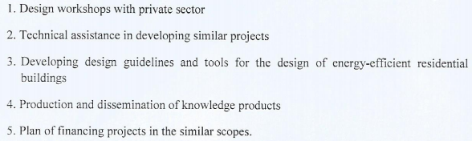
These tasks are all in TAs, they do not need a $65 million loan. Please provide more information on how to use the loan.

11/14/2019 MY:
Not completed. The information provided by the Agency on financing as shown in Box 8 (Box 8: Indicative public and private sector low-carbon investments associated with the LCUD Project.) is not sufficient for the PM to judge the cost-effectiveness of the project. Please add more information such as the MW of RE to be installed, the MWh of energy to be saved, and the source of financing to Box 8.

4/27/2020 MY:
Yes, comments were addressed, and the CEO ER document was revised.

Response to Secretariat comments

sans-serif

Response to 11/14/2019 MY:
Thanks for this guidance. We’ve now updated Box 8 in the UNDP project document with more specific information, including MW of RE installed, MWh energy savings, and sources of financing. For ease of reference, we’ve pasted Box 8 below.

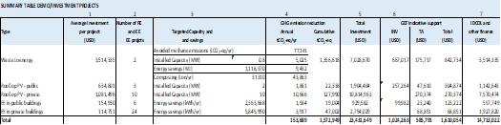

29 Oct, 2019 - MH

The above tasks are in the scope of TA that are emphasized by IDCOL for facilitating accelerated investments in the sector through the de-risking approaches and enabling framework proposed by the project in component 2. They correspond to the barriers noted through consensus in the stakeholder meetings conducted as a part of the PPG implementation.

Please also see the response to #1 above. The project’s component 2 will provide the TA support to a range of public and private sector project developers, some of which may access the IDCOL facility, and some of which may access other sources of debt and equity.

4. Does the project take into account potential major risks, including the consequences of climate change, and describes sufficient risk response measures? (e.g., measures to enhance climate resilience)
Secretariat Comment at CEO Endorsement
9/3/2019 MY:
Not completed. Please take into account potential risk due to climate change.
10/31/2019 MY:
Yes, comments were addressed and issues were cleared.

Response to Secretariat comments

sans-serif

29 Oct. 2019 - MH
Yes. The project considers prioritizing climate resilience projects for cities with rapid population growth and coastal location as integral to the “LCUD” concept. It has been specially included in Section 4.3 (Box 9). It may be note that the Outputs 1.2, 1.3 and 2.1 with MLGRDC and the ongoing UNDP National Urban Poverty Reduction Programme (NUPRP), implemented by MLGRDC would include pro-poor climate-resilient urban planning.
5. Is co-financing confirmed and evidence provided?
Secretariat Comment at CEO Endorsement
9/3/2019 MY:
Not completed at this time.
Please see the comments in Box 3 above. The co-financing letter from the IDCOL does not show how the $65 million will be invested. Please provide a concrete investment plan, such as MW of RE power to be invested in a particular place, etc.

10/31/2019 MY:
Not completed at this time.
Please see comments in Box 2.

11/14/2019 MY:
Not at this time.
This project now is in the stage of CEO ER. The Agency should provide information on secured co-financing, rather than "indicative co-financing". With the following response from the Agency on the issue of $65 million co-financing, the PM finds it difficult to recommend this project to the CEO for endorsement:
"In parallel to the above, IDCOL has a USD 65m loan facility for rooftop solar and EE investments. Consultations with IDCOL have identified that project developers are not presenting bankable investment opportunities for the loan facility. The relationship of this IDCOL facility to the project is that this IDCOL facility will be one possible source of financing for the project’s indicative investments, represented in Box 8. However, the indicative investments in Box 8 will also seek to raise financing from other debt and equity providers. IDCOL can be considered parallel co-financing, which is associated and well-aligned with the project, and for which there will be close coordination with project."

4/27/2020 MY:
Not completed at this time.
Please provide the email of the IDCOL email dated 24 November 2019, which confirms the loan co-financing of $65 million for the project. The PM cannot find the letter in the GEF Portal.
Also, the UNDP should also change the co-financing of $57,000 from in-kind to grant for this project. A revised co-financing letter to show the change from the UNDP is needed.

Response to Secretariat comments

sans-serif
Agency Response: 4/28/2020

Referred email from IDCOL and an updated co-financing letter indicating the contribution of $57,000 in grant by UNDP are attached.

Response to 11/14/2019 MY:
Thanks for this question and we provide the following clarification:
- The USD 65m IDCOL co-financing is fully secured, as per the original co-financing letter dated 6 December 2018. IDCOL have now further reconfirmed this co-financing in a new email dated 24 November 2019, which we are attaching to this submission.
- The term ‘indicative’ was introduced in the UNDP project document while responding to the earlier comments with a view to emphasize that these investments will follow standard practice for project financing - via due process under IDCOL’s, and other equity investor’s, investment committees and will need to be approved in due course.

29 Oct. 2019 - MH
Please also see the response to #1 above.

In terms of a breakdown of the project’s investments, please see Box 8 in the project document (page 45), which sets out a preliminary analysis performed during the PPG stage of 45 indicative investments, totaling USD 23.4m, in RE, EE and WTE.

The IDCOL co-financing letter does not breakdown specific investment as the IDCOL $65m loan facility is limited to parallel co-financing, which is well-aligned with the project objective and for which there will be close coordination. The project’s investments may seek financing from the IDCOL facility, but these investments may also seek debt and equity financing from other sources.

6. Are relevant tracking tools completed?
Secretariat Comment at CEO Endorsement
9/3/2019 MY:
Yes.

Response to Secretariat comments

sans-serif

7. Only for Non-Grant Instrument: Has a reflow calendar been presented?
Secretariat Comment at CEO Endorsement
9/3/2019 MY:
N/A

Response to Secretariat comments

sans-serif

8. Is the project coordinated with other related initiatives and national/regional plans in the country or in the region?
Secretariat Comment at CEO Endorsement
9/3/2019 MY:
Yes. it is stated on pages 12-15.

Response to Secretariat comments

sans-serif

9. Does the project include a budgeted M&E Plan that monitors and measures results with indicators and targets?
Secretariat Comment at CEO Endorsement
9/3/2019 MY:
Yes. it is stated on pages 12-15.

Response to Secretariat comments

sans-serif

10. Does the project have descriptions of a knowledge management plan?
Secretariat Comment at CEO Endorsement
9/3/2019 MY:
Yes. it is stated on pages 17.

Response to Secretariat comments

sans-serif

Agency Responses

11. Has the Agency adequately responded to comments at the PIF stage from:
GEFSEC

Secretariat Comment at CEO Endorsement
9/3/2019 MY:
No additional comments were carried over from the GEF at the PIF stage to the CEO ER stage.

Response to Secretariat comments

sans-serif

STAP

Secretariat Comment at CEO Endorsement
9/3/2019 MY:
Yes. The comments were addressed and shown on pages 24-26.

Response to Secretariat comments

sans-serif

GEF Council

Secretariat Comment at CEO Endorsement
9/3/2019 MY:
Yes. The comments were addressed and shown on pages 24.

Response to Secretariat comments

sans-serif

Convention Secretariat

Secretariat Comment at CEO Endorsement
9/3/2019 MY:
N/A

Response to Secretariat comments

sans-serif

Recommendation

12. Is CEO endorsement recommended?
Secretariat Comment at CEO Endorsement
9/3/2019 MY:
Not at this time.

Please address comments in Boxes 2, 3, 4 and 5.
For major issues, please elaborate how the $65 million loan will be invested and put more detailed information in outputs of Component 2.2. For example, the number EE buildings and about MW of RE to be installed in specific locations, etc. The co-financing letters from the loan provider may also need to elaborate these tangible investments. Other minor issues include identifying the risk of climate change for this project.
10/31/2019 MY:
Not completed at this time. Please address the comments above.
11/14/2019 MY:
Not at this time.
The project co-financing is not convincing. Please work on secured co-financing, not "indicative" co-financing for the implementation of the project.
4/27/2020 MY:
Not completed at this time.
Please provide the email of the IDCOL email dated 24 November 2019, which confirms the loan co-financing of $65 million for the project.
The UNDP should also change the co-financing of $57,000 from in-kind to grant. A co-financing letter to show the change is needed. Thanks.

Response to Secretariat comments

Agency Response 4/28/2020

Referred email from IDCOL and an updated co-financing letter attached.

Response to 11/14/2019 MY:
Thanks again for these comments. Please see our responses above regarding further clarity on co-financing.

Separately, in an effort to support the GEF review of this project, given ongoing discussions on this topic on other projects, UNDP would like to take this opportunity to pre-emptively re-confirm that this project has a clear delineation between implementation (UNDP) and execution (SREDA). The project will be executed by the national partner, Sustainable and Renewable Energy Development Authority (SREDA).

